**Cookbook Network**

**Created By:**

Hernandez, Anais

Oyarzun, Erico

Shah, Aqib

CEN 4010 - Software Engineering I

Spring 2015

# 

# **Table of Contents**

Table of Contents

I. What is Cookbook Network?

II. Why Use Cookbook Network?

III. How To Access Cookbook Network?

General Functions

Guest User Functions

Registered User Functions

Administrator Functions

V. Help

VI. Database Tables

# 

# 

# **I. What is Cookbook Network?**

*Welcome to Cookbook Network!*

The Cookbook Network is a virtual recipe book where users will be allowed to share recipes with one another and create their own cookbooks with their favorite recipes. The objective of this application is to have users post recipes, and allow users to search and find recipes they are interested in a quick and simple manner. Each recipe will consist of an image, ingredients, steps, ratings or flags, and short tags. These short tags will describe the type of food that is being made in the recipe, making searching for recipes easier and precise for the user. The Cookbook Network will help users keep track of their favorite recipes by adding it to their cookbook, instead of having to search for it each time. A diverse group of users will be able to enjoy the site, sharing and discovering new recipes from different parts of the world.

# **II. Why Use Cookbook Network?**

Although Cookbook Network may seem like just another food web site, it is so much more than that. There are nearly endless benefits of utilizing Cookbook Network!

To give a few examples, with Cookbook Network you can share multiple recipes within a matter of seconds and explore several recipes that you didn’t even know existed! You can become a master culinary chef using the recipes and impress all of the people that matter to you. Furthermore, you can use Cookbook Network recipes and cookbooks to create diet and help you reach the weight you’ve always wanted! There are so many possibilities!

# **III. How To Access Cookbook Network?**

Accessing Cookbook Network is as easy as 1-2-3. Simply grab your favorite electronic device, type in [www.cookbooknetwork.com](http://www.cookbooknetwork.com) into the browser and press GO!

**IV. Getting Started**

Nomenclature

Before we begin diving into the many functions of Cookbook Network, let’s go through some common terminology that is utilized throughout the paper.

**The Homepage** -

The homepage, Figure 1, is the first page visible when you navigate to [www.cookbooknetwork.com](http://www.cookbooknetwork.com). To enter the website, one of the three options near the bottom right of the page can be selected.

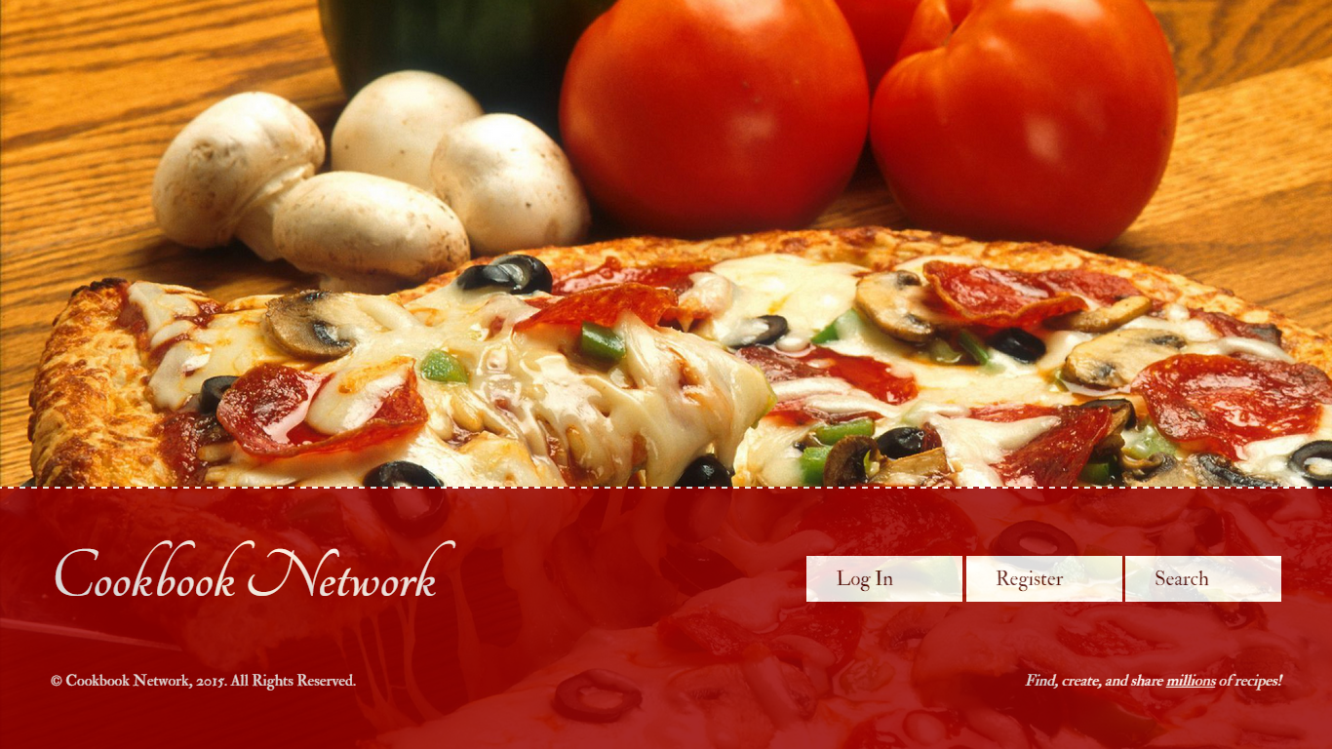**Figure 1 - Home Page**

**The Content Pages** -

The content pages are any pages other than the home page. These pages will often be referred to by the title on the page. For example, the page shown in Figure 2 would referred to page View Recipe Page.

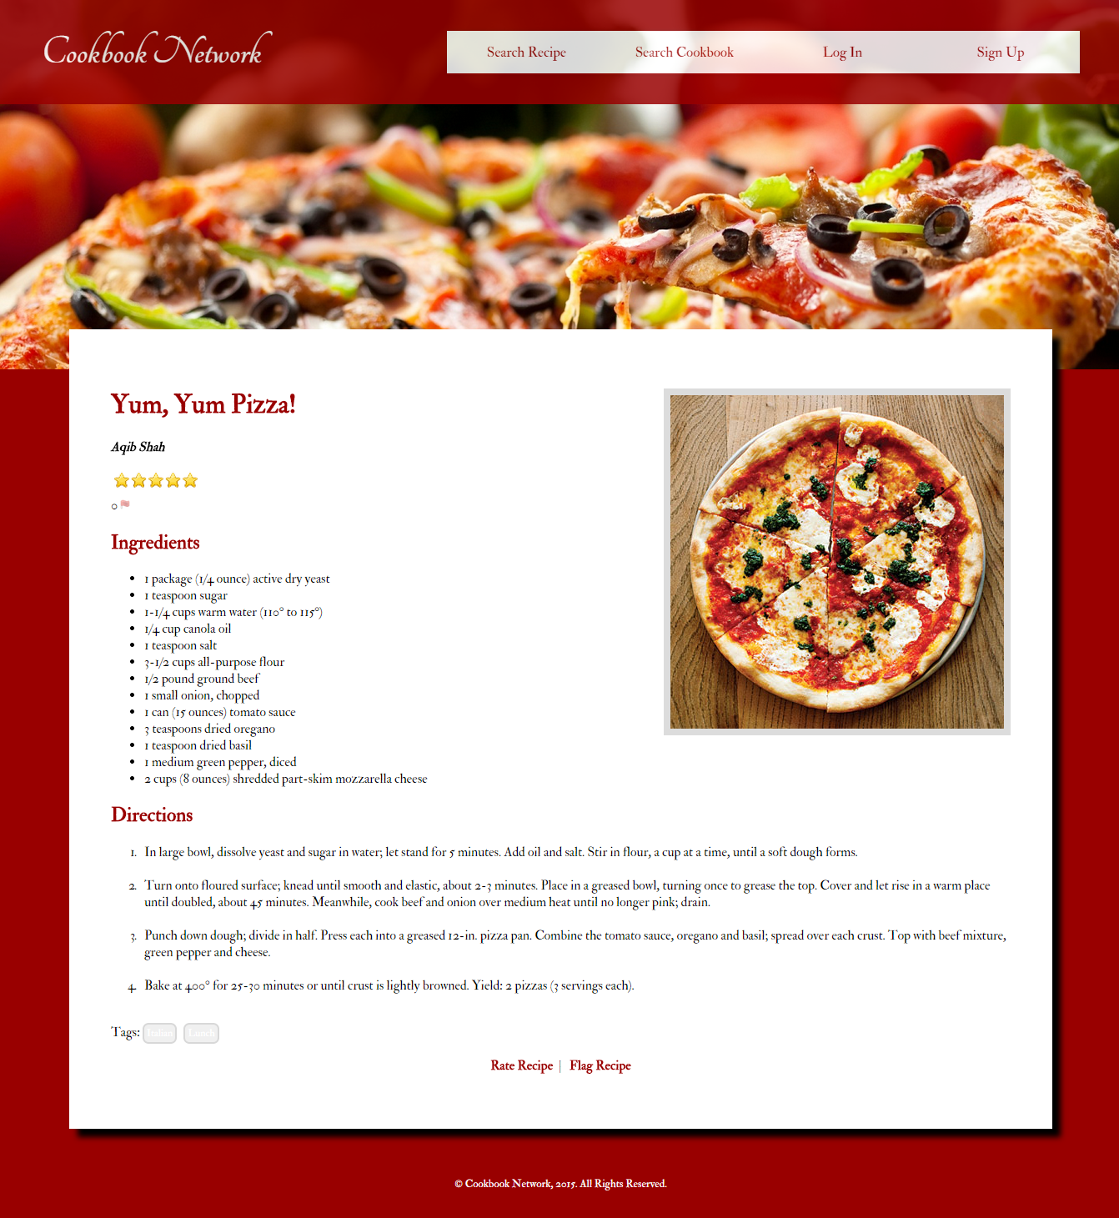

**Figure 2 - View Recipe Page**

**The Navigation Bar** -

*Present on every page (except the homepage), the navigation bar can be used to travel to any accessible page at any time. The navigation bar can be simplified into four different tabs that perform several different functions (to see more information about each function please look further down where each function is described in detail).*

For a Guest User (see below for more details on the different types of users), the four tabs are as follows:

1. Search Recipe -

*This tab allows users to search for specific recipes by providing some criteria.*

1. Search Cookbook -

*Like Search Recipe, this tab allows users to search for cookbooks the given specifications.*

1. Log In -

*Using this tab, the user can log in to their registered account, if they have one.*

1. Sign Up -

*Users that do not have a registered account with Cookbook Network can register an account using the Sign Up tab.*



**Figure 3 - Navigation Bar for Guest User**

For Registered Users and Administrators the navigation bar is broken down into four different categories and more options can be seen by hovering over the following tabs:

1. Search Tab -

*This tab comprises both functions of ‘Search Recipe’ and ‘Search Cookbook’. To see these two functions, simply hover over the Search* *tab.*



**Figure 4 - Search Tab for Registered User**

*Administrators will also have the option to ‘Search and Browse Accounts’.*

**Figure 5 - Search Tab for Administrator**

1. Recipe Tab -

*This tab provides functions involving recipes, such as creating a recipe or viewing previously created recipes.*



**Figure 6 - Recipe Tab for Registered User**

*Administrators will also have the right to ‘View Flagged Recipes’.*



**Figure 7 - Recipe Tab for Administrator**

1. Cookbook Tab

*This tab contains functions regarding cookbooks, such as creating cookbook function and viewing previously created cookbooks.*



**Figure 8 - Cookbook Tab for Registered User**

1. Account Tab

*This tab may be utilized to perform any available account functions, such as logging out and viewing account information.*



**Figure 9 - Account Tab for Registered User**

*Administrators will be also be able to view all registered accounts and delete a user using this tab.*

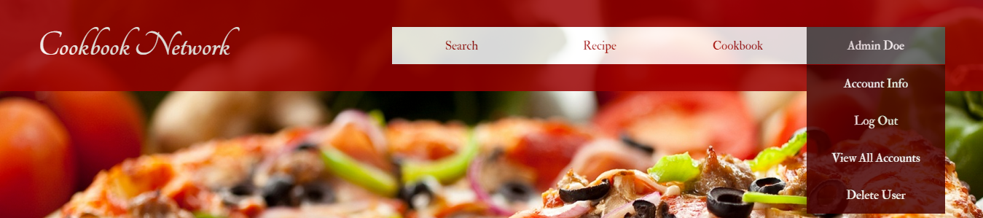 **Figure 10 - Account Tab for Administrator**

## General Functions

*These group of functions are available to any type of user, and therefore any one that accesses Cookbook Network.*

**Search and Browse**

*Although there are several recipes and cookbooks available on Cookbook Network, the recipes or cookbooks can be narrowed down based on some criteria including ingredients, name, and tags. To search and browse recipes, follow the steps below:*

1. For Guest Users, select either Search Recipe or Search Cookbook, as shown in Figure 11. For registered users or administrators hover over the Search Tab in the Navigation Bar and select either Search Recipe or Search Cookbook, as shown on Figures 4 and 5.



**Figure 11 - Search Tab for Guest User**

1. On the Search Recipe Page, shown on Figure 12, enter the desired criteria, such as name of recipe, ingredients, or browse by tags.

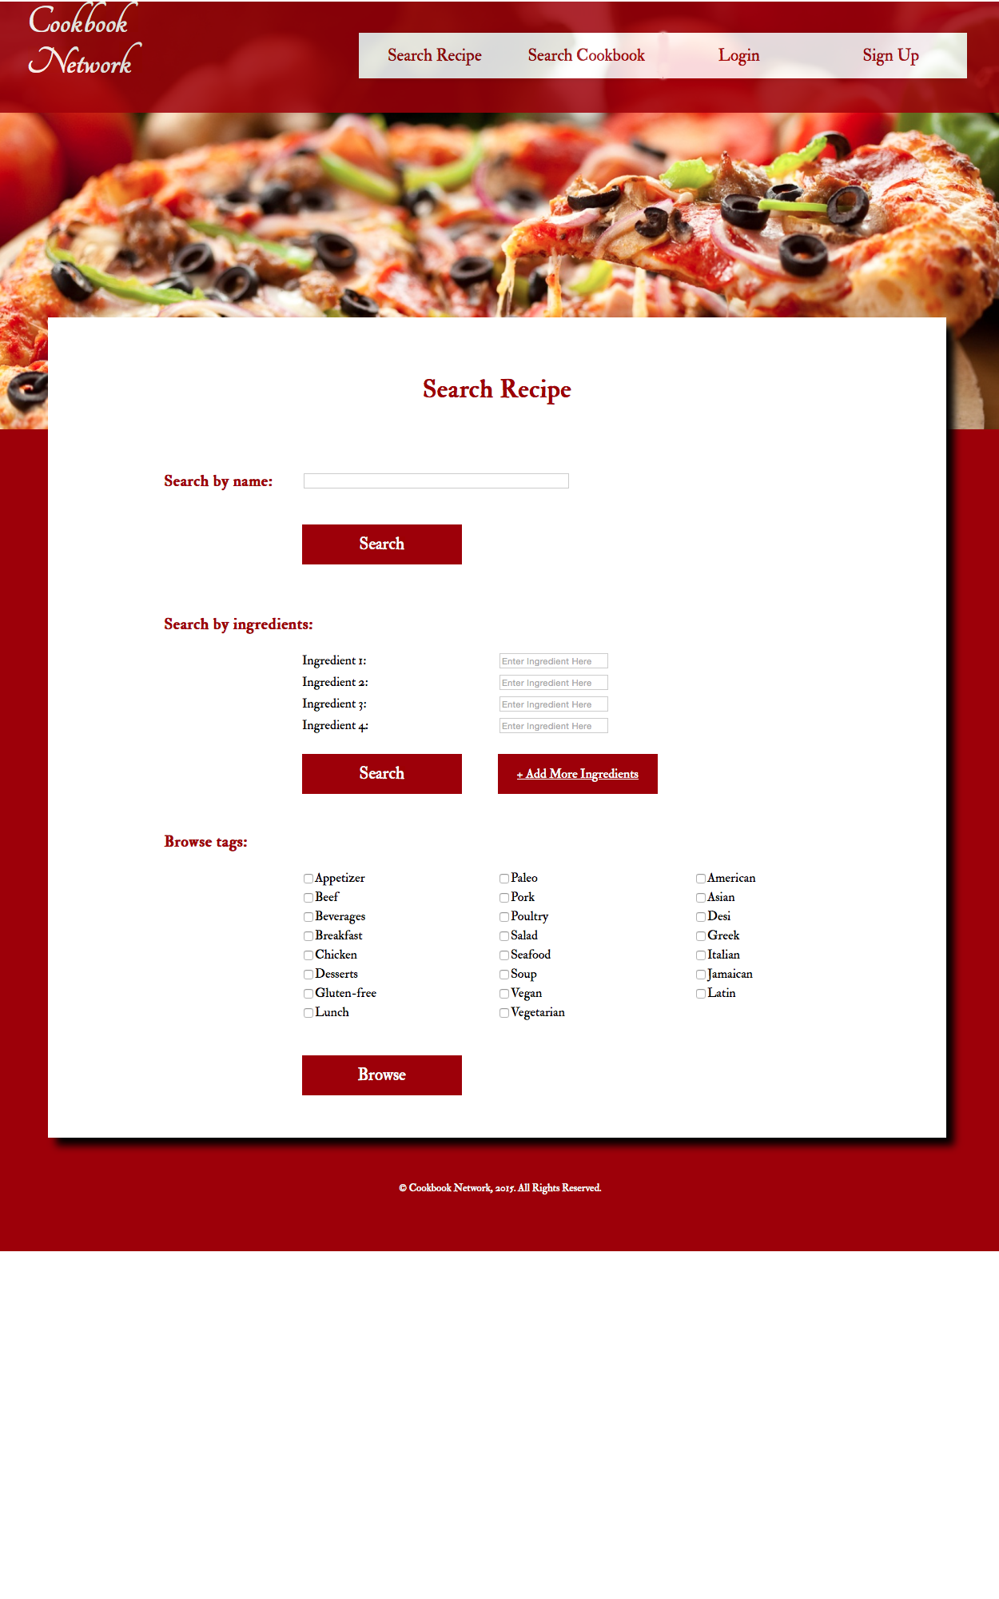

**Figure 12 - Search Recipe Page**

1. On Search Cookbook Page, shown on Figure 13, enter criteria, such as name of cookbook or browse by cookbook tags.

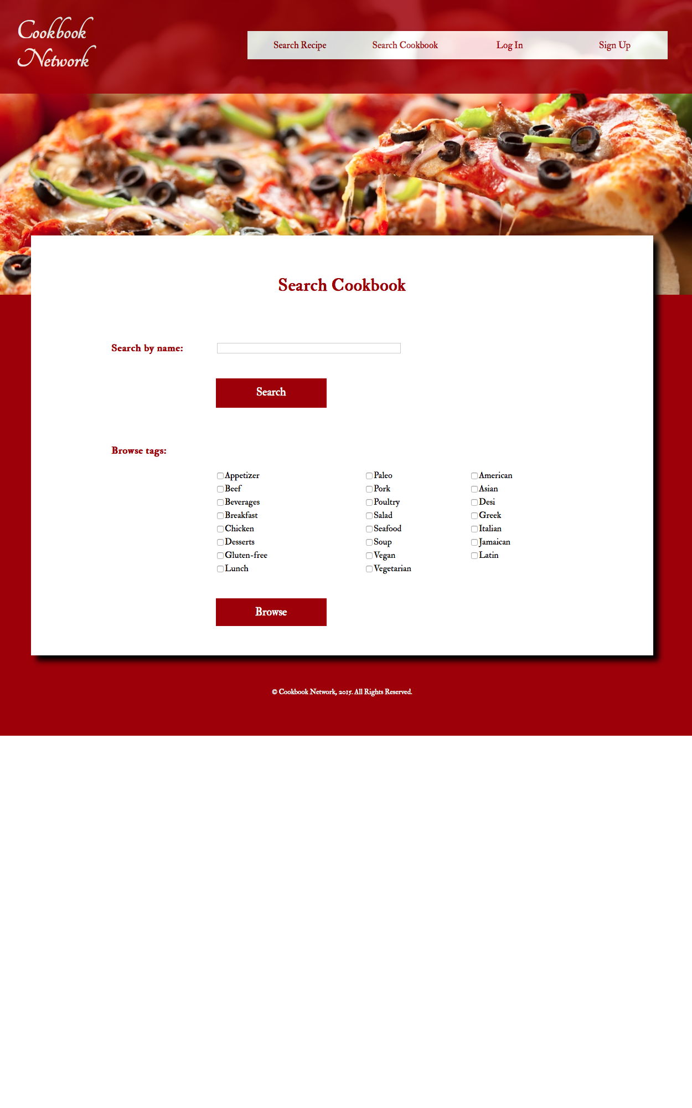

**Figure 13 - Search Cookbook Page**

1. To submit the search, click Search or Browse.
2. If the action was completed successfully, the search results will be displayed, like the one shown in Figure 15 or Figure 16. If the action fails, a Failure Page will be displayed as shown in Figure 14. If the latter is displayed, then none of the input fields were filled or no search results were found.

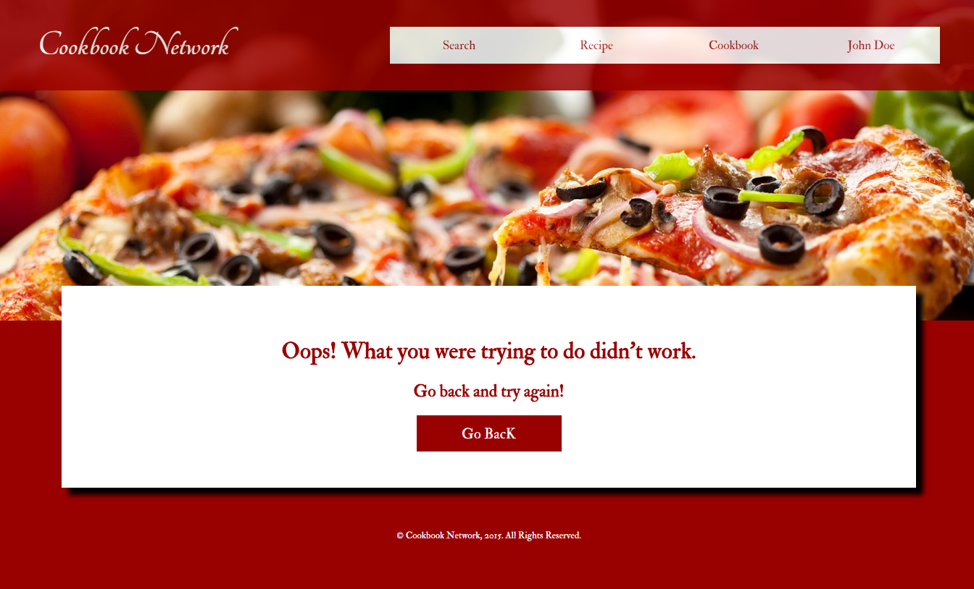

**Figure 14 - Failure Message Page**

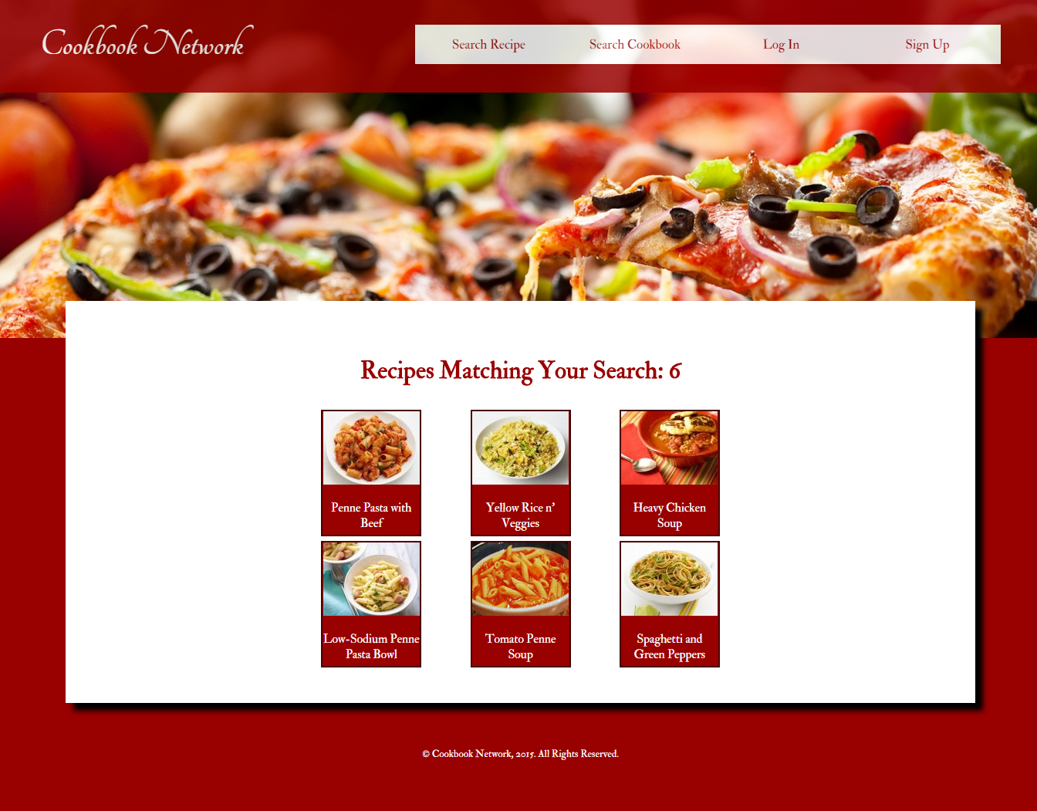

**Figure 15 - Recipe Search Results Page**

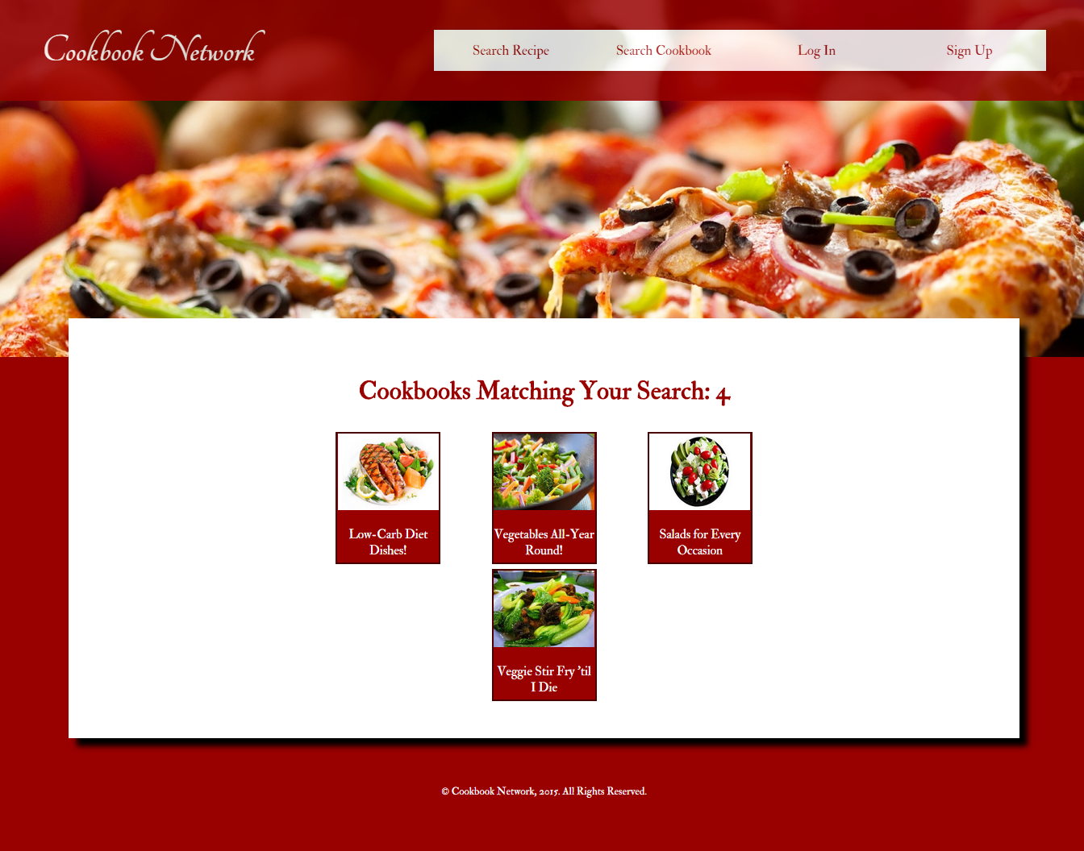

**Figure 16 - Cookbook Search Results Page**

**View Cookbook**

*After searching for a specific set of cookbooks, more details can be viewed by doing the following:*

1. To view a cookbook, simply select the desired cookbook in the cookbook search results, shown in Figure 15, and all of it’s containing recipes should be displayed, as seen on Figure 17.

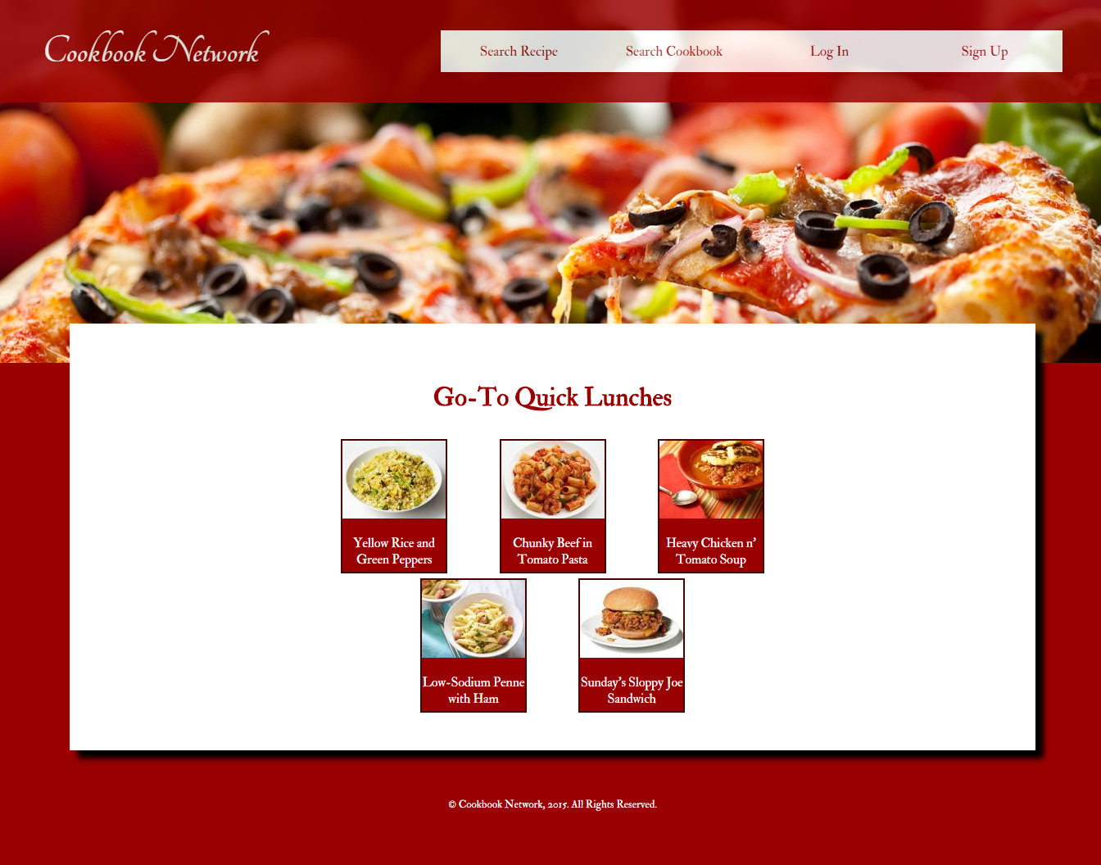

**Figure 17 - View Cookbook Page**

**View Recipe**

*To view more details about a certain recipe, simply do the following:*

1. To view a recipe, simply select the desired recipe from the search results, Figure 16, or from a recipe in a cookbook, Figure 17, and all of it’s contents should be displayed, shown in Figure 2.

## Guest User Functions

*If you do not have an account with Cookbook Network, you are considered a Guest User. Guest users have the privileges described below in addition to the General Functions.*

**Registering An Account**

*Registering an account means acquiring an account with Cookbook Network. With an account, you can upload recipes, create cookbooks, rate recipes, etc. To make an account, simply follow these steps:*

1. If on the Homepage, click the Register button shown in Figure 1. Otherwise, if on a Content Page, then simply click the Register Tab in the Navigation Bar as shown in Figure 3. This will take you to the Create Your Cookbook Network Account page displayed in Figure 18 below.

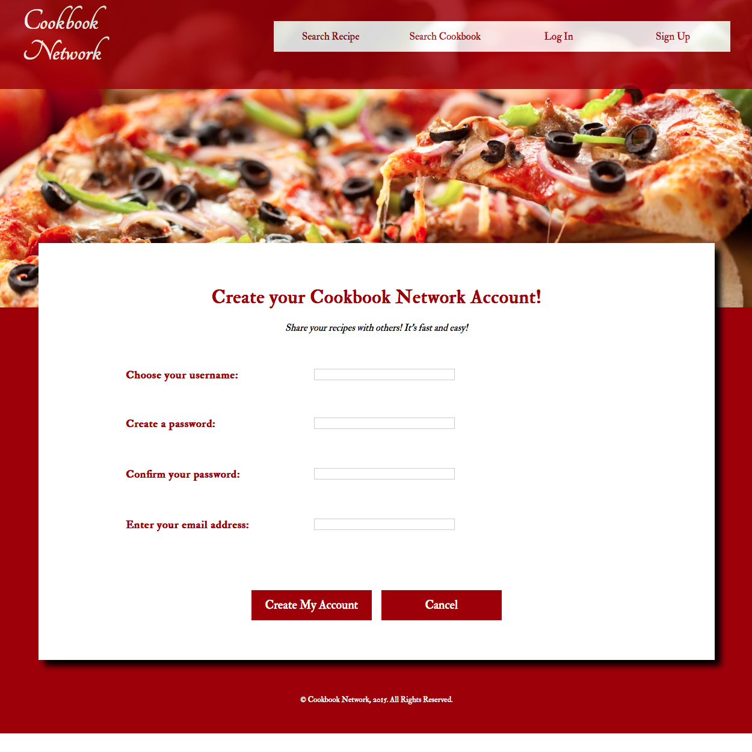

**Figure 18 - Create Your Cookbook Network Account Page**

1. Now, enter a username, and password twice followed by a valid email address. To finish registration, select the Create My Account button at the bottom of the page. To cancel, click Cancel that is also at the bottom of the page.
2. If the action was completed successfully, a Success Page will be displayed, like the one shown in Figure 19. If the action fails, a Failure Page will be displayed as shown in Figure 14. If latter is displayed, then either one or more of the fields were left empty, or the email entered is already registered to another account.

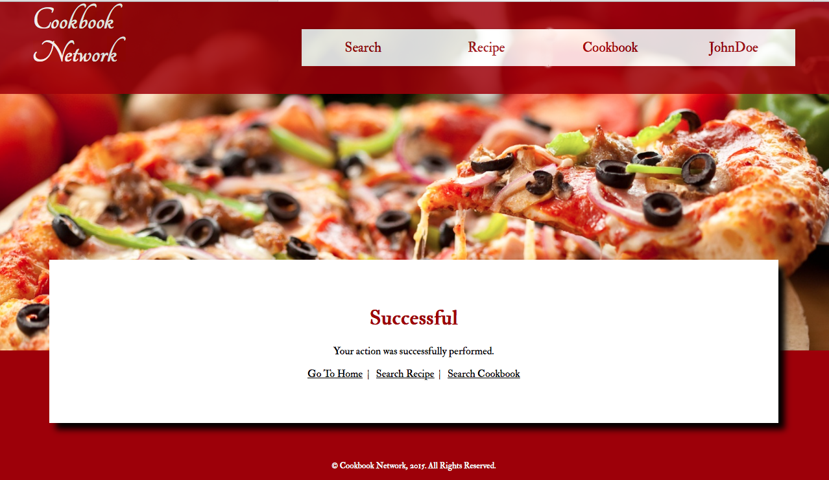

**Figure 19 - Success Message Page**

## Registered User Functions

*A registered user is a user with an existing account in the Cookbook Network. Registered users can perform the following functions as well as the Guest User Functions and General Functions. Most of these functions require the user to be logged in.*

**Log In To Account**

*If you already have an existing account in Cookbook Network you can log in by following these steps.*

1. From the Homepage, click on the Log In button as shown in Figure 1. Alternatively, you can login by clicking the Log In tab in the menu, as shown in Figure 3. This will direct you to the Login Page, as seen in the figure below.

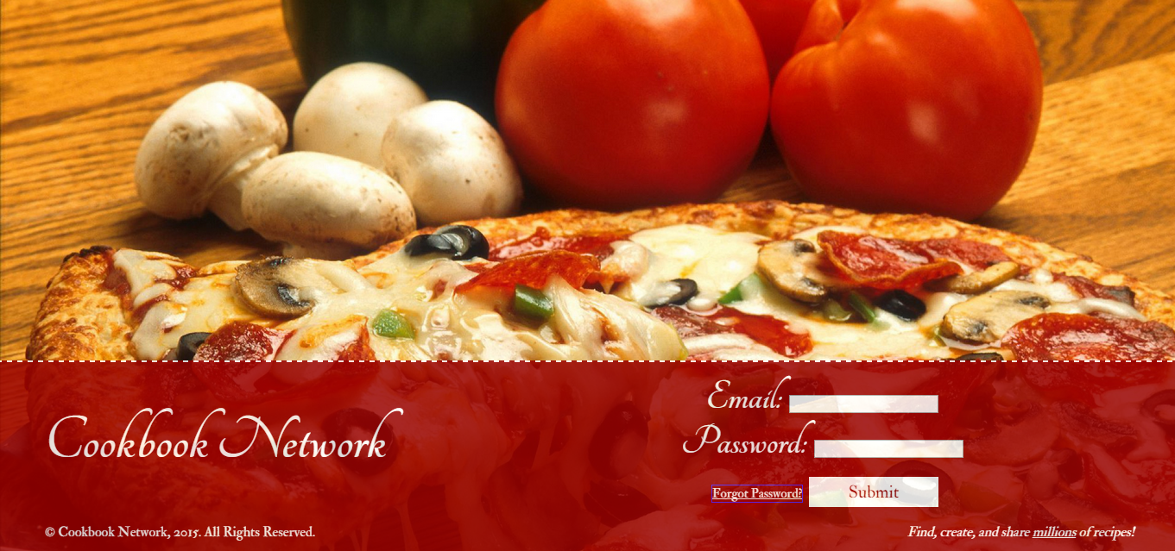

**Figure 20 - Log In Page**

1. In the Login Page, enter your email and password and click Submit.
2. If the action was completed successfully, a Success Page will be displayed, like the one shown in Figure 19. Furthermore, the user will be logged in. If the action fails, a Failure Page will be displayed as shown in Figure 14. If latter is displayed, then either one or more of the fields were left empty, or the email entered is not registered with Cookbook Network, or the email and password combination is incorrect.

**Forgotten Password**

*If you happen to forget the password to your account, do not worry, you can reset it following the steps below.*

1. Navigate to the Log In page and click Forgot Password.
2. Once at the Forgotten Password Page (shown in Figure 21), enter the email address of the account of which the password must be reset.

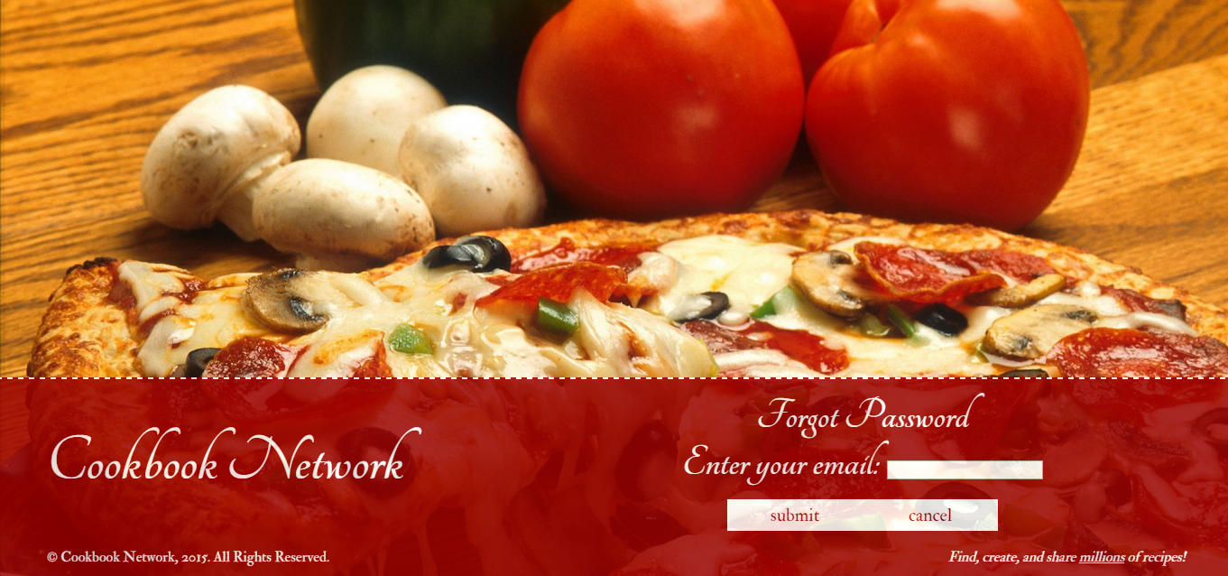

**Figure 21 - Forgot Password Page**

1. To submit, select Submit. To cancel, select Cancel.
2. If the action was completed successfully, a Success Page will be displayed, like the one shown in Figure 19. Furthermore, a randomized password will be sent to the email address that was entered in step 2. If the action fails, a Failure Page will be displayed as shown in Figure 14. If the latter is displayed, then either one or more of the fields were left empty, or the email entered is not registered with Cookbook Network.

**Change Password**

*If you wish to change your existing password, you can do so by following the steps below once you are logged in and in the account information page.*

1. Hover over the Accounts Tab in the Navigation Bar and select View Account Info, shown in Figure 9. This will take you to the the Account Info Page, shown in Figure 22.
2. Click Change Password towards the bottom of the screen.

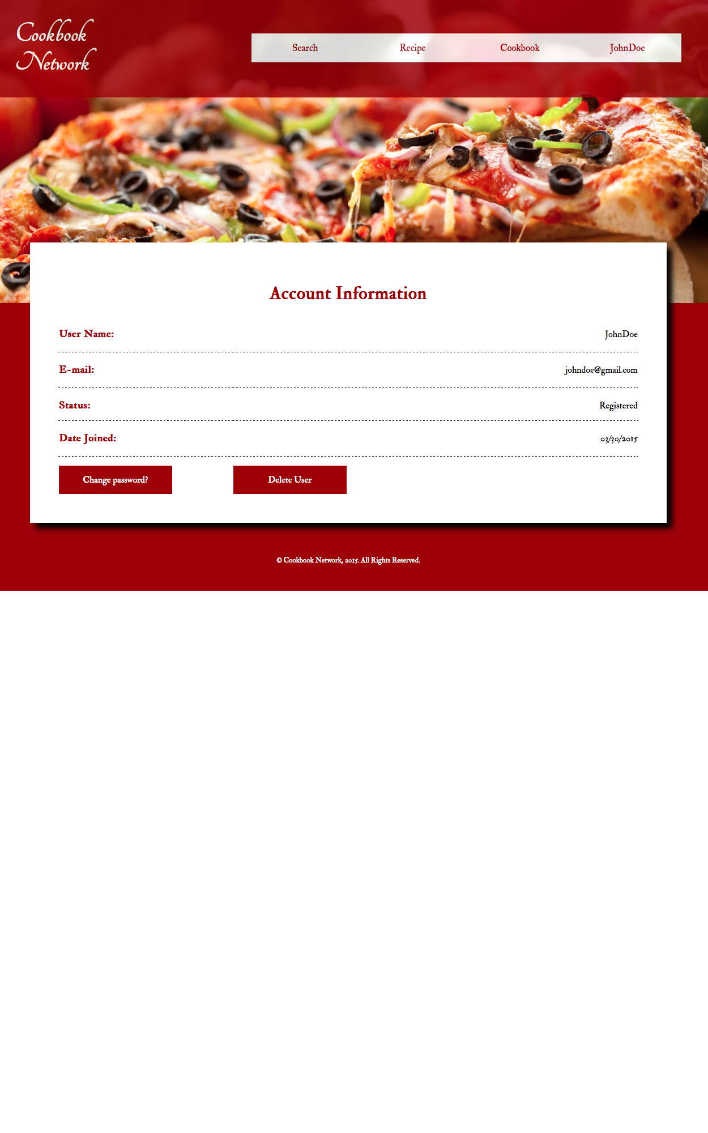

**Figure 22 - Account Info Page**

1. Once at Change Password Page enter current password and new desired password. Then, click Save Changes.

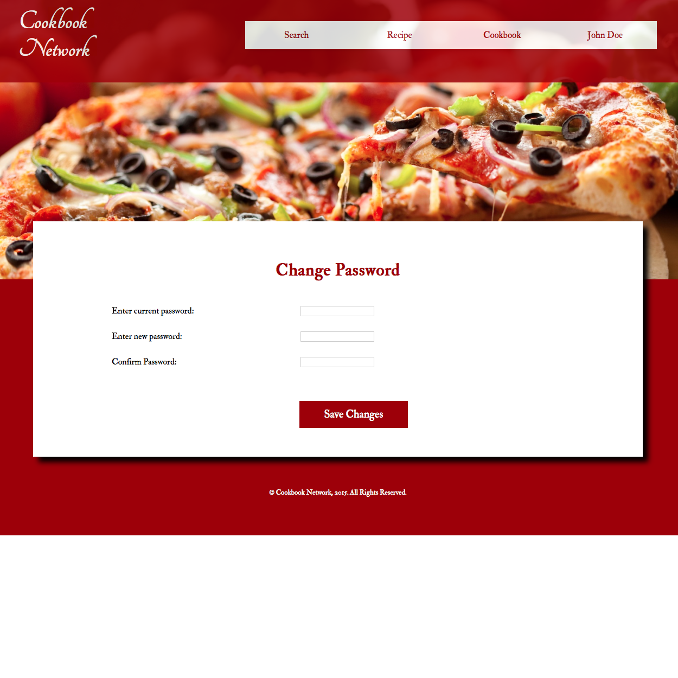

**Figure 23 - Change Password Page**

1. If the action is successful, Success Page will be displayed as shown in Figure 19. If current password is incorrect or new password does not match the confirm password, a Failure Page will be displayed as shown in Figure 14.

**View Account Information**

*To view more information about an account follow these designated steps:*

1. Hover over the Accounts Tab in the Navigation Bar and select View Account Info, shown in Figure 9.
2. The Account Information Page should be displayed as shown in Figure 21, in Change Password Section.

**Create Recipe**

*To create a recipe to share with others, follow these steps:*

1. From the Navigation Bar, click on Create Recipe (under the Recipe Tab) as shown in Figure 7.
2. The Create New Recipe Page. Figure 24, will be displayed: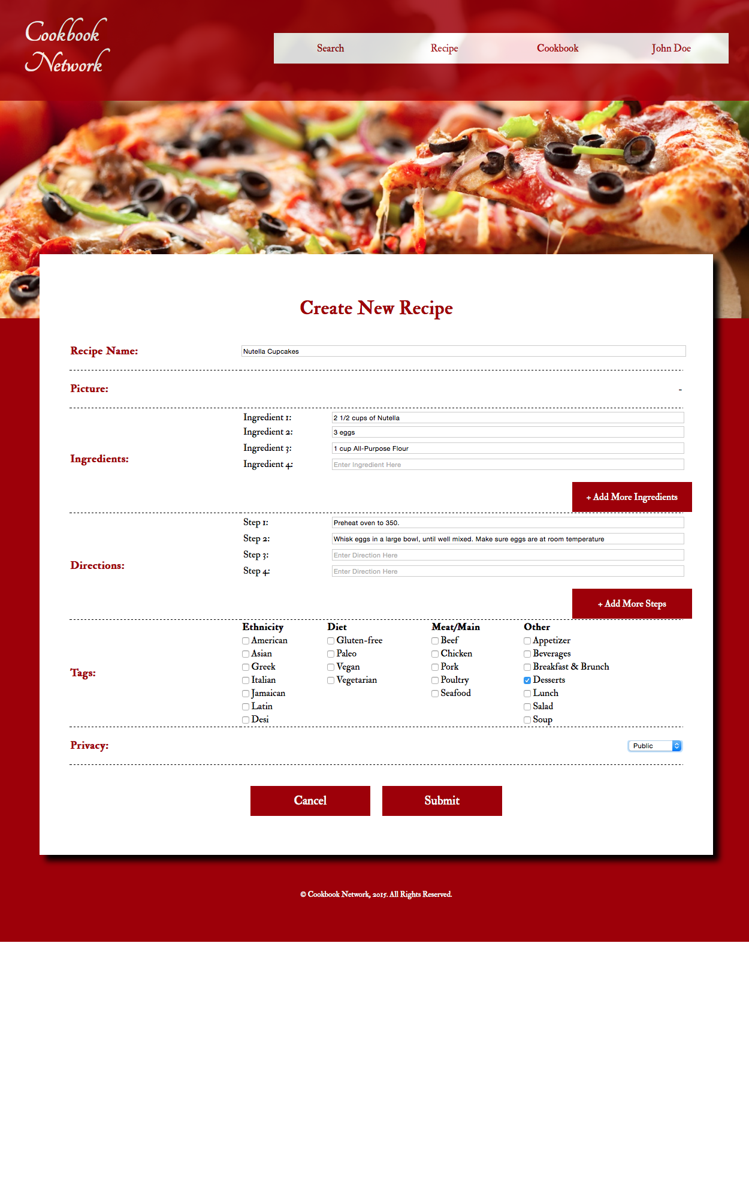

**Figure 24 - Create New Recipe**

1. Enter your recipe information in the fields, including title, ingredients, steps, tags, and privacy. If you wish to add more ingredients or steps, simply click on Add More Ingredients or Add More Steps respectively, and more fields will appear.
2. When you are finished entering the required fields, click Submit.. You may also choose to cancel, by selecting the Cancel option. If you decide you want to cancel you will be taken to the previously visited page.
3. If the action was completed successfully, a Success Page will be displayed, like the one shown in Figure 19. If the action fails, a Failure Page will be displayed as shown in Figure 14. If the latter is displayed, then either one or more of the fields were left empty.

**View Own Recipe**

*To view any previously created recipes, follow these steps:*

1. Hover over the Recipe Tab in the Navigation Bar to show the hidden options-- refer to Figure 7.
2. Select View myRecipes from the dropdown menu. This should display all of the previously created recipes as shown in Figure 24.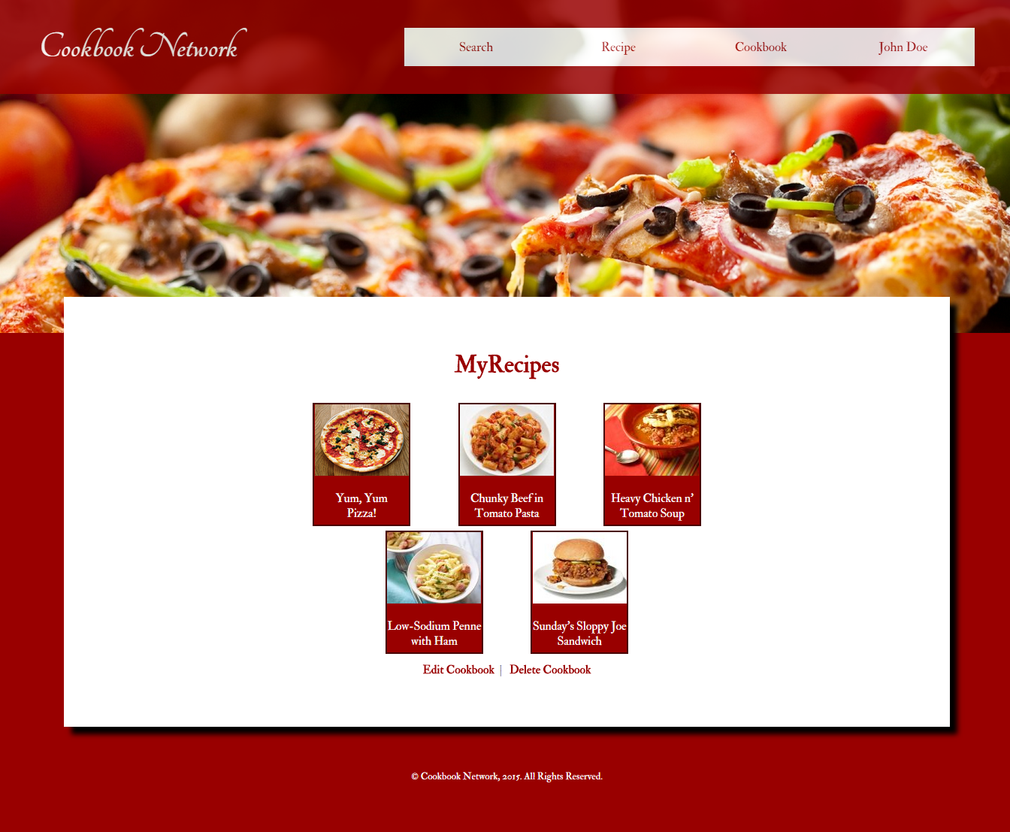

**Figure 25 - myRecipes Cookbook Page**

1. Click on the recipe you wish to see and a page like Figure 26 will be shown. From this page, you may edit or delete your own recipe. For further details on this step, please refer to View Recipe under General Functions.

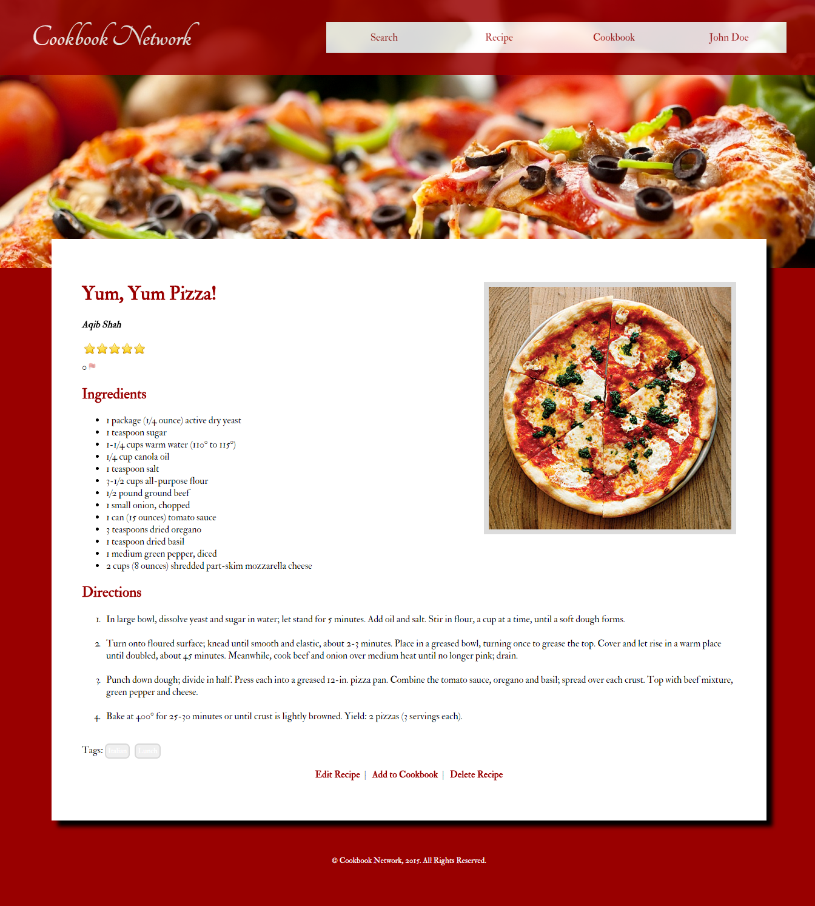

**Figure 26 - View Own Recipe**

**Edit Recipe**

*To make changes to a created recipe, such as changing the name, adding ingredients and steps, follow these steps:*

1. Navigate to the Recipe Page of the recipe that needs to be edited, as shown above in Figure 26.
2. Select the Edit Recipe link at the bottom of the page. Refer to Figure 27.
3. Once on the Edit Recipe Page, enter the desired changes and click Submit. You may also choose to cancel by selecting the Cancel button.

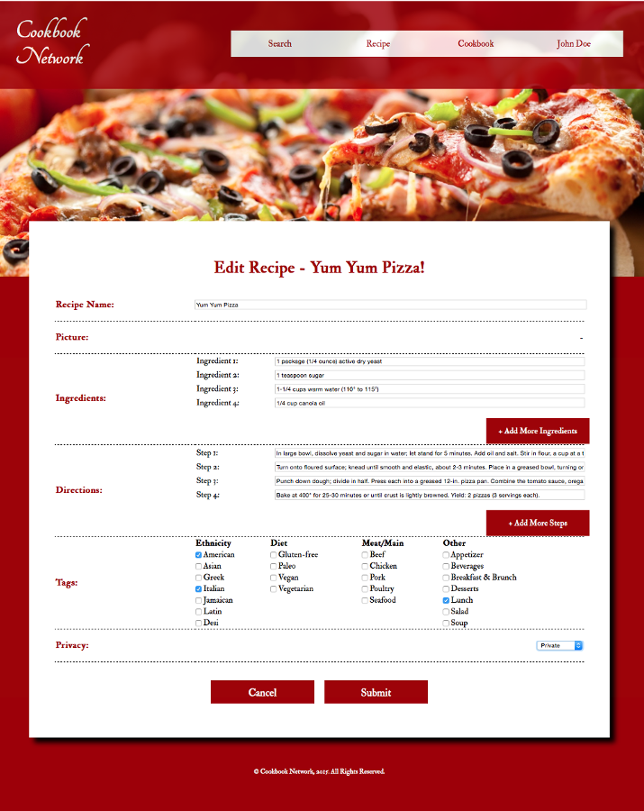

**Figure 27 - Edit Recipe Page**

1. If the action was completed successfully, a Success Page will be displayed, like the one shown in Figure 19. If the action fails, a Failure Page will be displayed as shown in Figure 14. If the latter is displayed then either one or more of the fields were left empty.

**Delete Recipe**

*To delete a recipe that was previously created, do the following:*

1. Navigate to the Recipe Page of the recipe that needs to be deleted. Note, this recipe must be authored by the user deleting it.
2. Select the Delete Recipe link at the bottom of the View Own Recipe seen on Figure 26.
3. A Confirmation Page should be displayed. To confirm the delete, select Confirm. To cancel the delete, select Cancel.

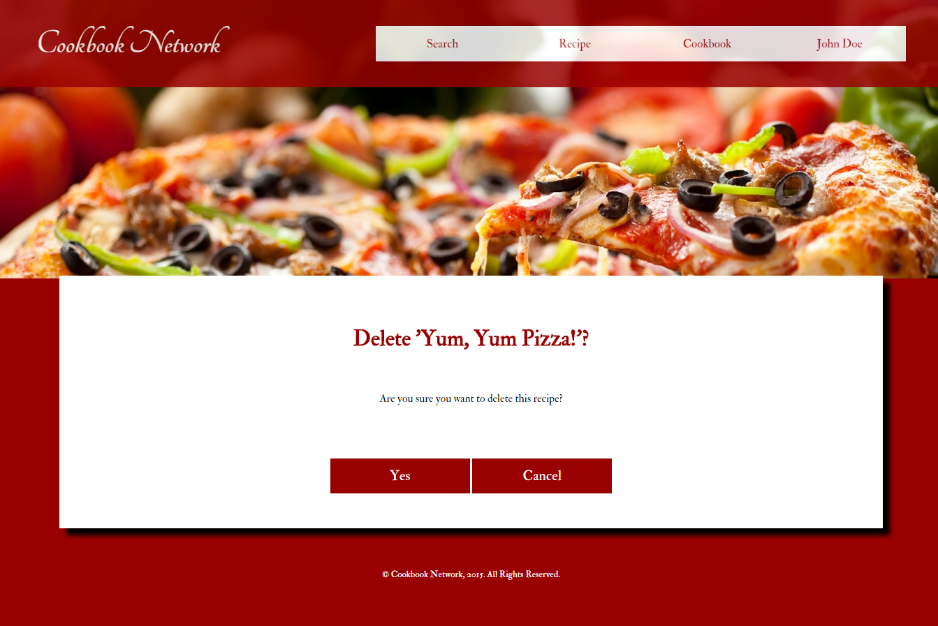

**Figure 27 - Delete Recipe Confirmation Page**

1. If the action was completed successfully, a Success Page will be displayed, like the one shown in Figure 19. If the action fails, a Failure Page will be displayed as shown in Figure 14. If latter is displayed then please try again. If the failure page persists, please let us know using the help information at the end of this document.

**Add Recipe To Cookbook**

*To add a recipe to a cookbook that you are interested in and want to save, follow these steps:*

1. In the Recipe Page currently being viewed, scroll to the bottom of the page and click Add To Cookbook, as shown in Figure 28. This will take you to the Add to Cookbook Page.

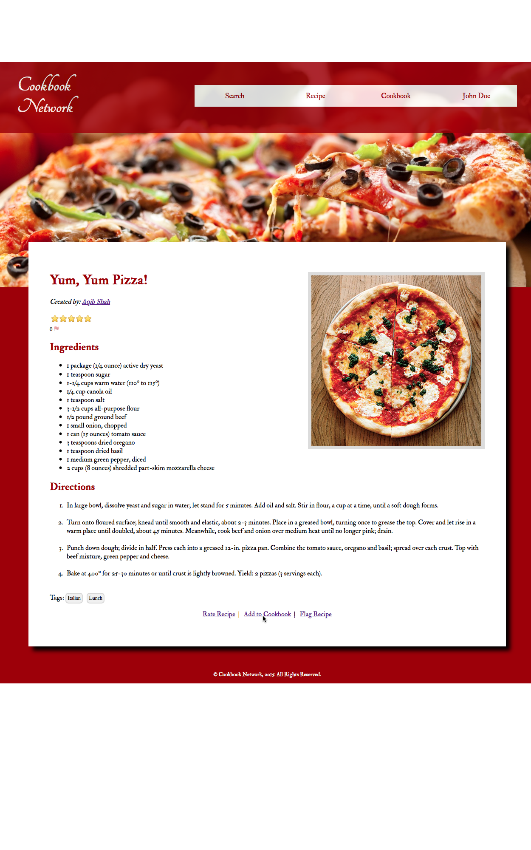

**Figure 28 - Add to Cookbook Option in View Own Recipe Page**

1. From the dropdown list of Cookbooks, choose the desired cookbook to add it to and click Submit to add recipe to cookbook or Cancel to cancel as shown in Figure 29.

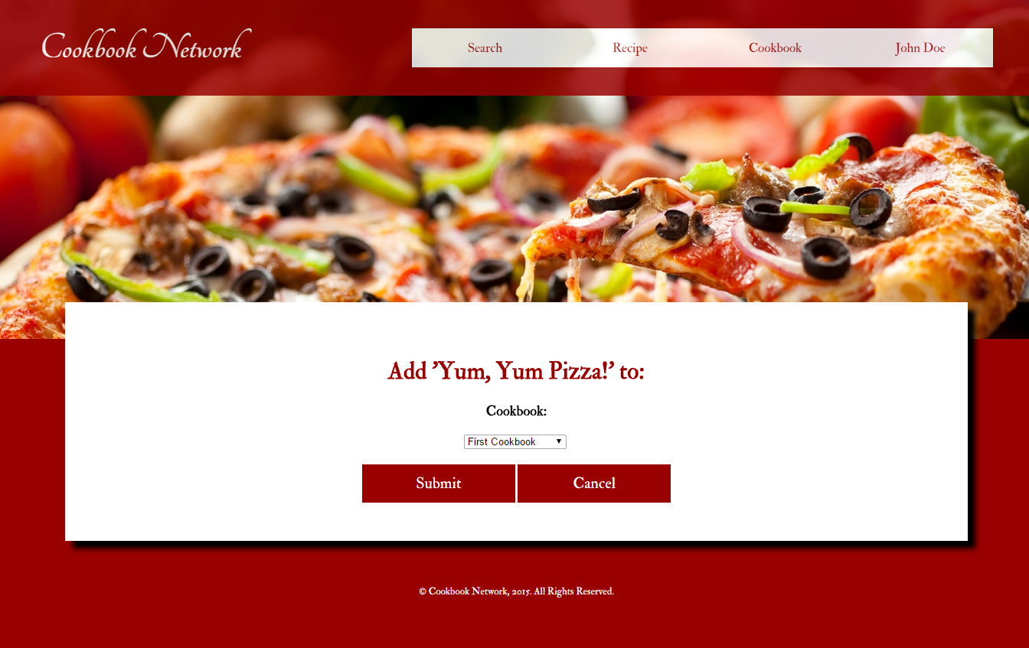

**Figure 29 - Add Recipe to Cookbook Page**

1. If the action was completed successfully, a Success Page will be displayed, like the one shown in Figure 19. If the action fails, a Failure Page will be displayed as shown in Figure 14. If latter is displayed then please try again. If the failure page persists, please let us know using the help information at the end of this document.

**Rate Recipe**

*To rate the recipe you are currently viewing, follow the steps below:*

1. Select the Rate Recipe link.
2. Once on the Rate Recipe Page, select the desired rating visible in Figure 30.

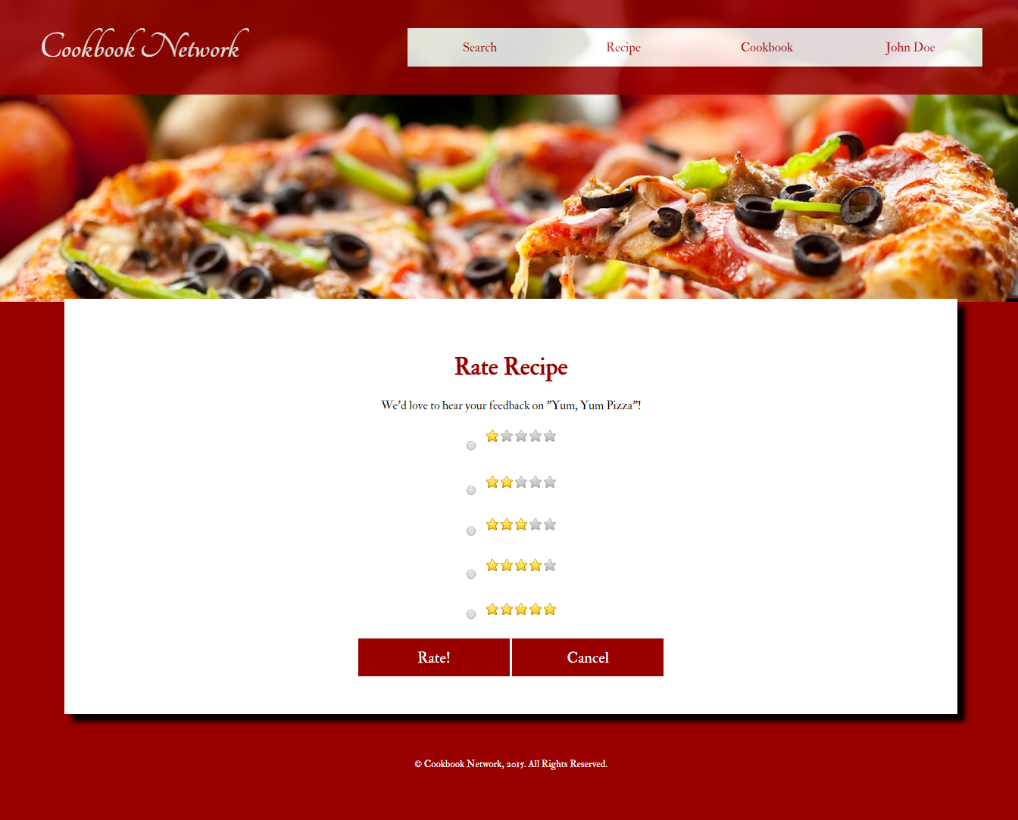

**Figure 30 - Rate Recipe Page**

1. To submit the rating, select Submit. To cancel, select Cancel. If you decide you want to cancel you will be taken to the previously visited page.
2. If the action was completed successfully, a Success Page will be displayed, like the one shown in Figure 19. If the action fails, a Failure Page will be displayed as shown in Figure 14. If latter is displayed then please try again. If the failure page persists, please let us know using the help information at the end of this document.

**Create Cookbook**

*To create a new assortment of recipes, additional cookbooks can be created by:*

1. Hover over the Cookbook Tab in the Navigation Bar and select Create Cookbook.
2. Once on the Create Cookbook Page, enter a name for the cookbook, the desired privacy setting, and select some relevant tags.

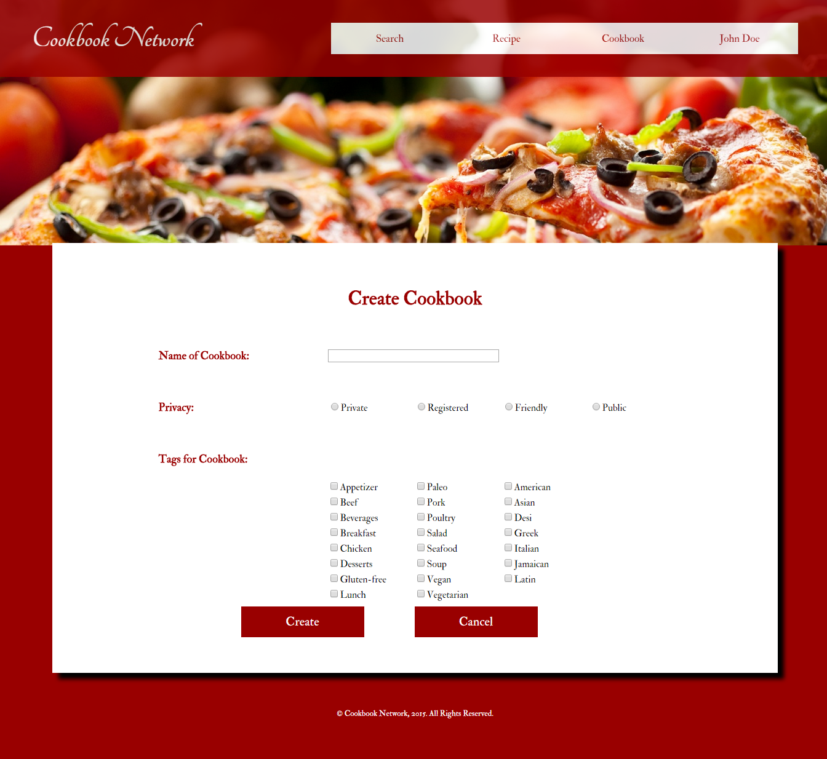

**Figure 31 - Create Cookbook Page**

1. To finally create the cookbook, select Submit. To cancel, select Cancel. If you decide you want to cancel you will be taken to the previously visited page.
2. If the action was completed successfully, a Success Page will be displayed, like the one shown in Figure 19. If the action fails, a Failure Page will be displayed as shown in Figure 14. If latter is displayed then the name field must have been left blank.

**Edit Cookbook**

*To modify a previously created cookbook, follow these steps:*

1. Navigate to the cookbook that is to be modified and select Edit Cookbook towards the bottom of the page. Refer to View Cookbook section and Figure 17.
2. Make the desired changes to the cookbook, such as change in name or tags. To submit the changes, click Save Changes. To cancel, select Cancel. If you decide you want to cancel you will be taken to the previously visited page.

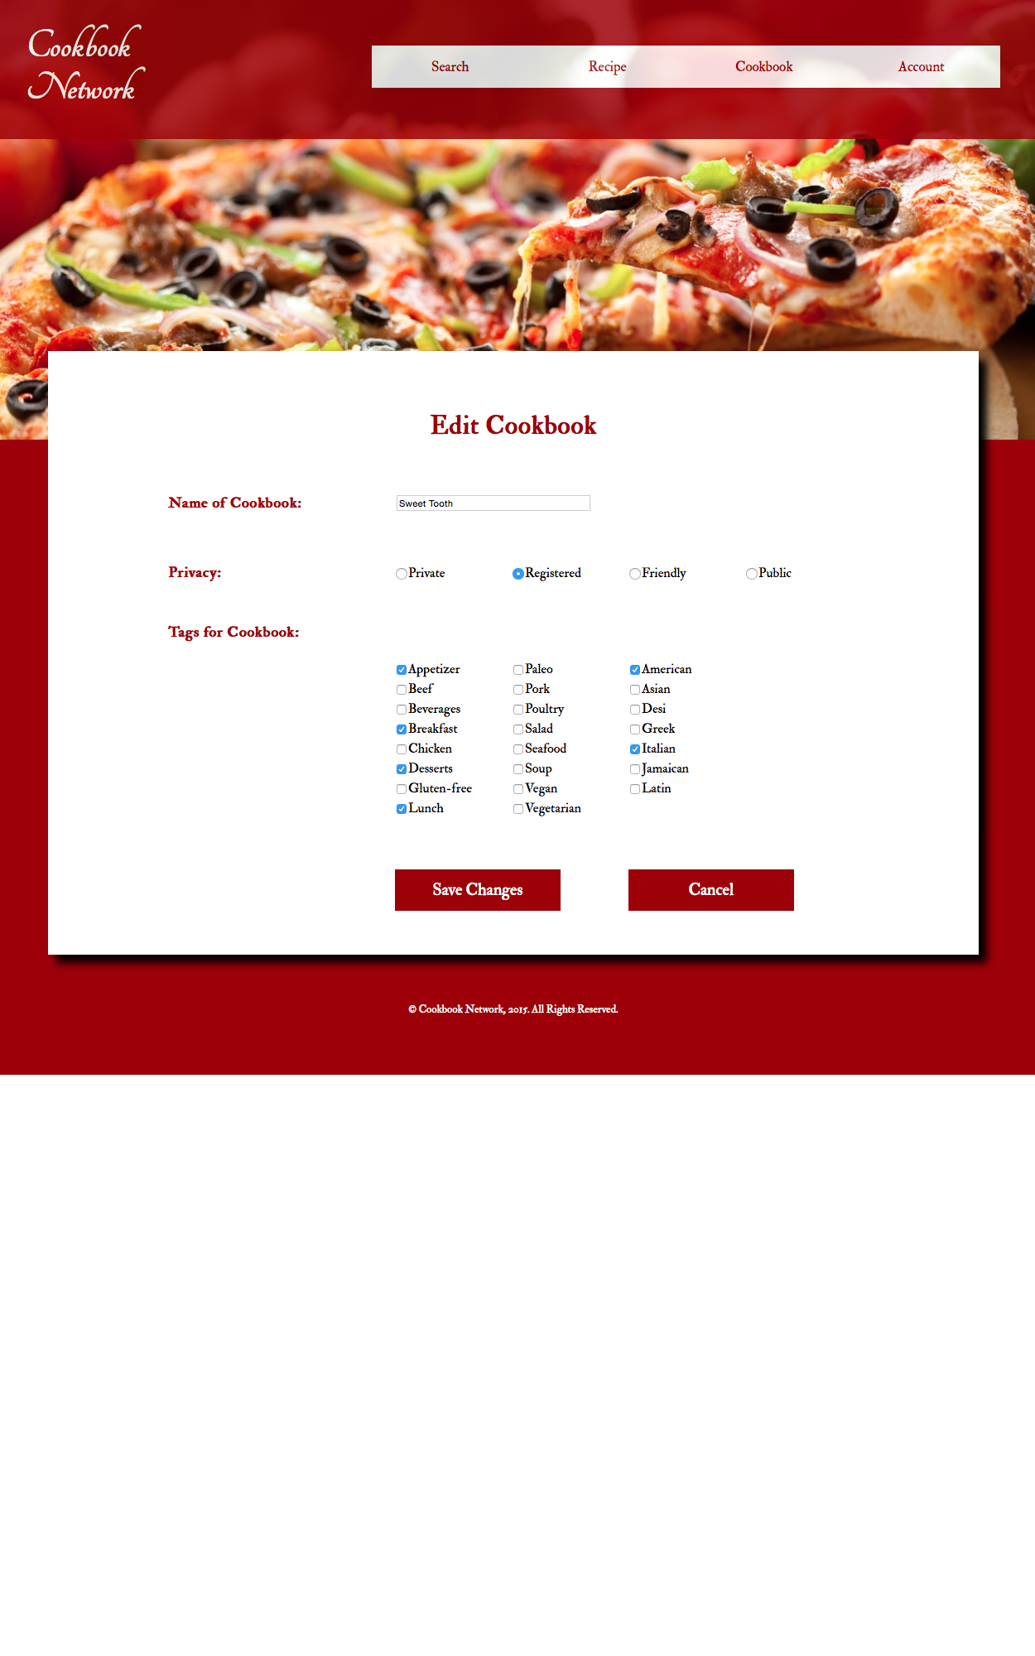

**Figure 32 - Edit Cookbook Page**

1. If the action was completed successfully, a Success Page will be displayed, like the one shown in Figure 19. If the action fails, a Failure Page will be displayed as shown in Figure 14. If latter is displayed then a field may have been left blank.

**Delete Cookbook**

*In order to delete a cookbook from Cookbook Network, please follow the steps below:*

1. Navigate to the cookbook that is to be deleted and select Delete Cookbook towards the bottom of the page. Refer to View Cookbook section and Figure 17.
2. Select the Delete Cookbook link at the bottom of the page as displayed on Figure x.
3. A Confirmation Page should be displayed. To confirm the delete, select Yes. To cancel the delete, select Cancel.

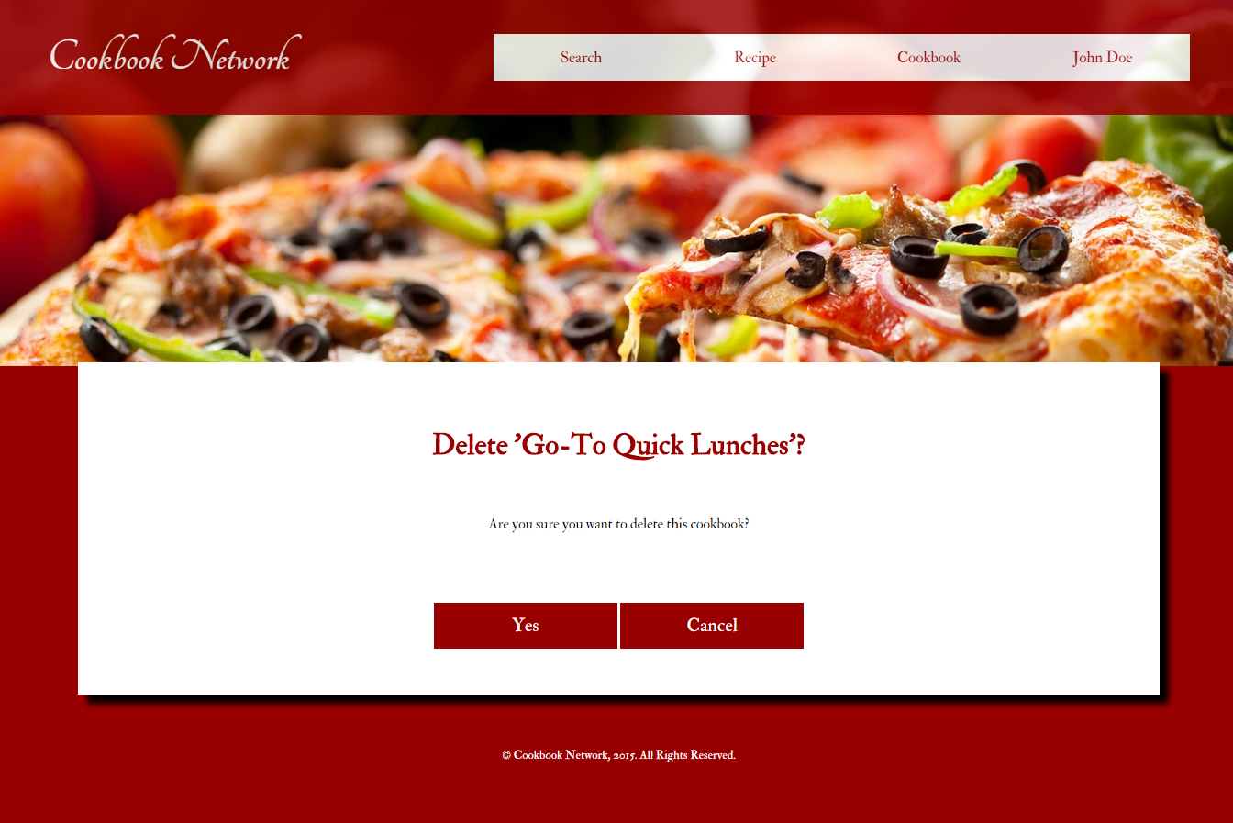

**Figure 33 - Delete Cookbook Confirmation Page**

1. If the action was completed successfully, a Success Page will be displayed, like the one shown in Figure 19. If the action fails, a Failure Page will be displayed as shown in Figure 14. If latter is displayed then please try again. If the failure page persists, please let us know using the help information at the end of this document.

**Flag Recipe**

*If a recipe has inappropriate language, misleading tags, or misleading directions, it can be flagged by doing the following:*

1. Navigate to the Recipe Page of the recipe that needs to be flagged.
2. Select the Flag Recipe link at the bottom of the page as displayed on Figure 2.
3. Complete the flag form by providing a reason and a comment. To submit the changes, click Submit. To cancel, select Cancel. If you decide you want to cancel you will be taken to the previously visited page.

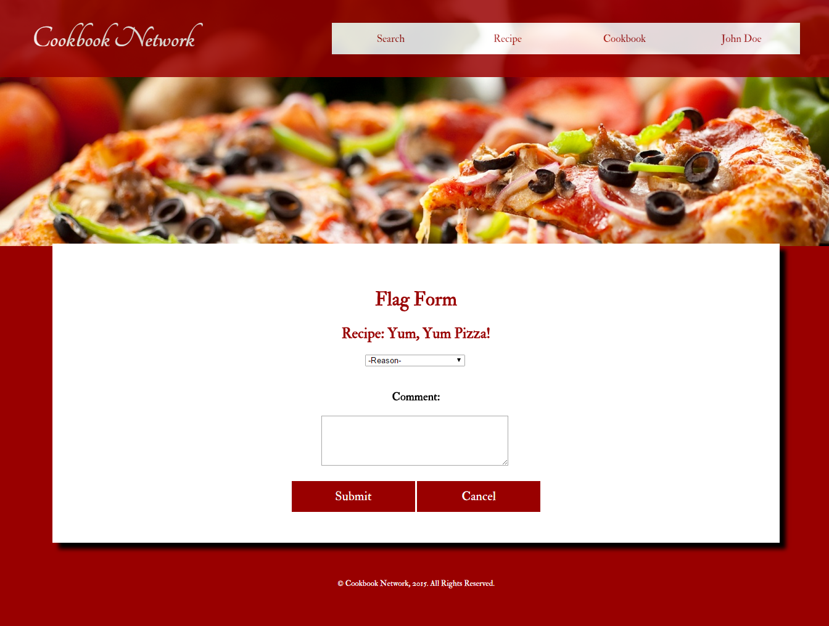

**Figure 34 - Flag Form Page**

1. If the action was completed successfully, a Success Page will be displayed, like the one shown in Figure 19. If the action fails, a Failure Page will be displayed as shown in Figure 14. If latter is displayed then please try again. If the failure page persists, please let us know using the help information at the end of this document.

**Log Out of Account**

*Once logged in, the user can log out by following these steps:*

1. Hover over the Account Tab in the Navigation Bar, Figure 9, and select Log Out.
2. If the action was completed successfully, the Homepage will be displayed, like the one shown in Figure 19. If the action fails, a Failure Page will be displayed as shown in Figure 14. If latter is displayed then please try again. If the failure page persists, please let us know using the help information at the end of this document.

## Administrator Functions

*Administrators are registered users, but are specially selected by other administrators. They serve special functions in order to keep the site a friendly and enjoyable space. In order to complete their tasks, administrators have the follow privileges (in addition to all of the ones described above):*

**View Flagged Recipes**

*In order to moderate the recipes, administrators can view flagged recipes by following these steps:*

1. Hover over the Recipes Tab in the Navigation Bar and select View Flagged Recipes.
2. All of the flagged recipes should be displayed as shown below in Figure 35.

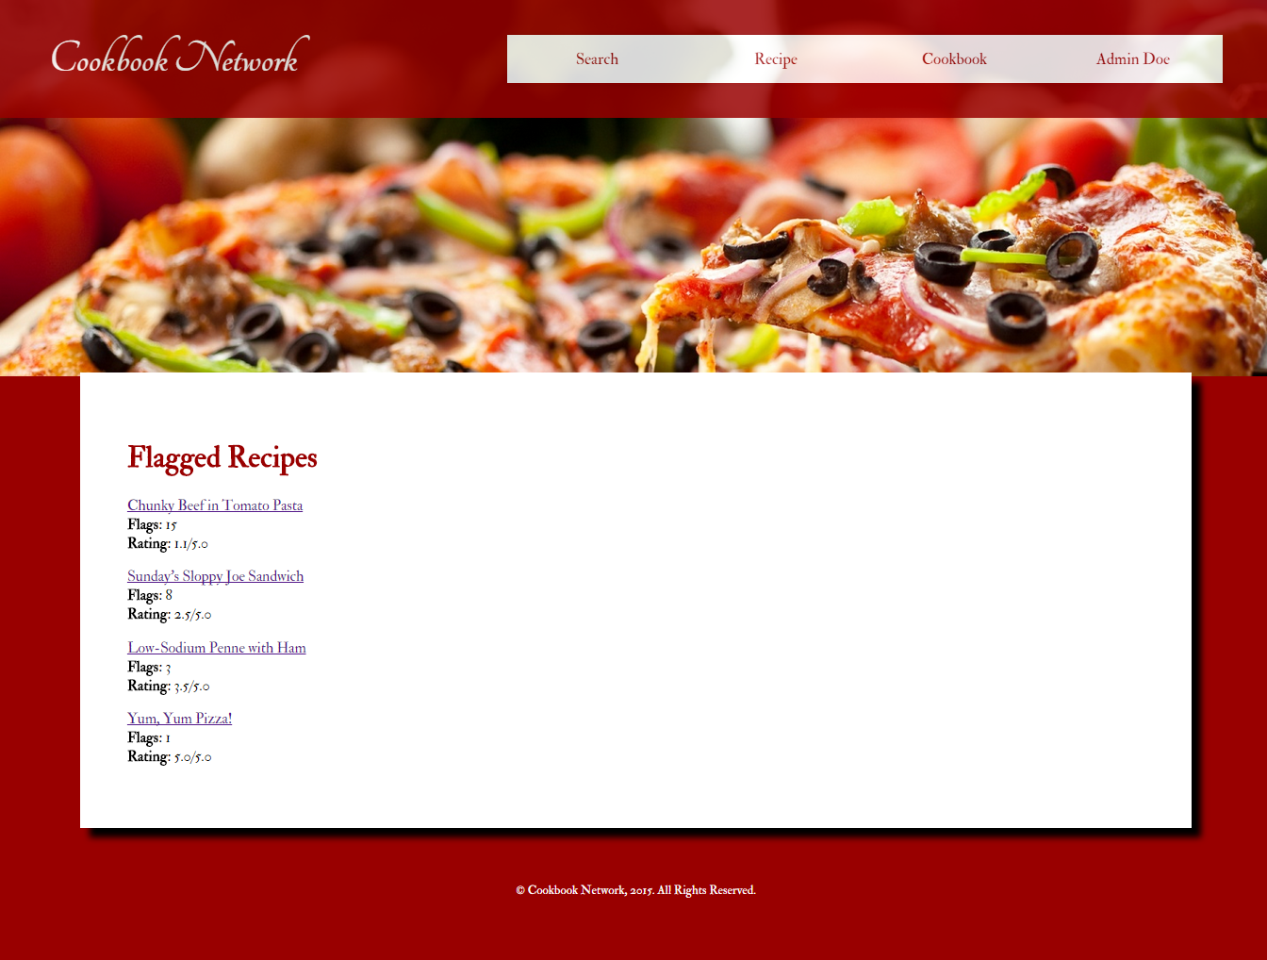

**Figure 35 - View Flagged recipes Page**

**View All Accounts**

*In order to keep record of all of the users, administrators can view all registered accounts by following these steps:*

1. Hover over the Account Tab in the Navigation Bar and select View All Accounts.
2. All registered accounts should be displayed as shown in Figure 36.

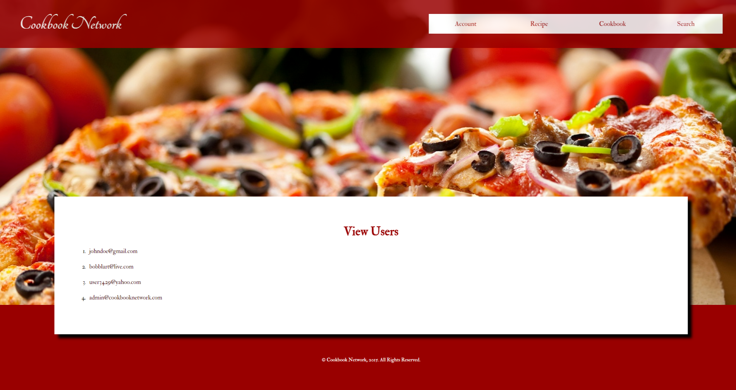

**Figure 36 - View All Accounts Page**

**Search and Browse Accounts**

*Administrators can search for specific users by doing the following:*

1. Hover over the Search Tab in the Navigation Bar and select Search Accounts.
2. The email address of the desired user should be entered. To submit, select Submit. To cancel, select Cancel. If you decide you want to cancel you will be taken to the previously visited page.

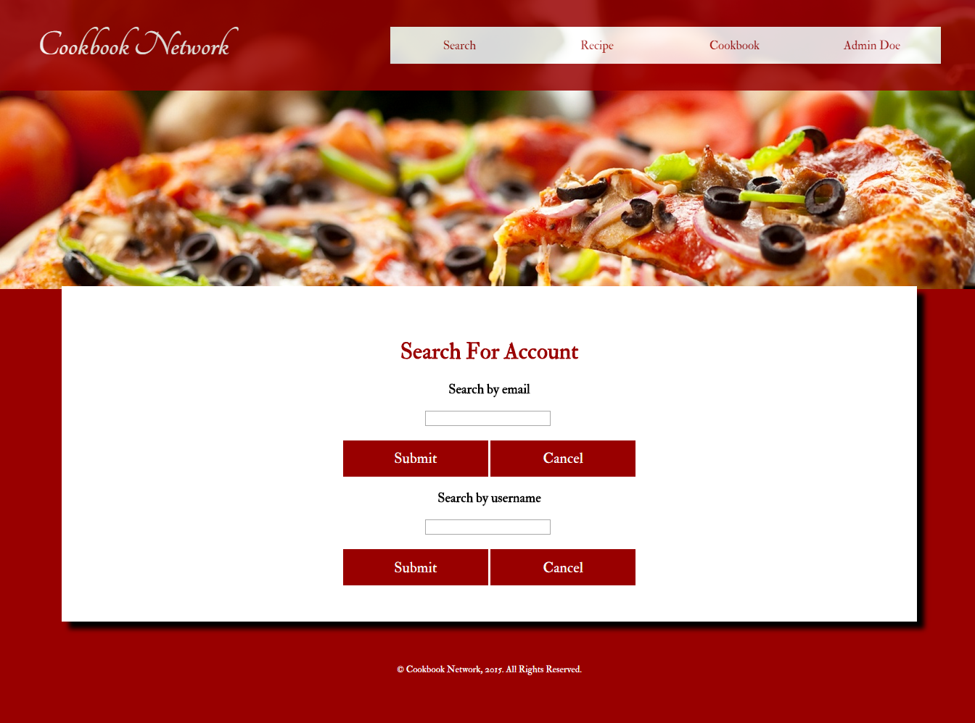

**Figure 37 - Search for Account Page**

1. If the action was completed successfully, the administrator will be taken to the user’s account information page. If the action fails, a Failure Page will be displayed as shown in Figure 14. If the latter is displayed, then the email field must have been left blank.

**Delete User**

*An administrator may delete a user that violates Cookbook Network’s terms of conditions. By deleting a user, their account will be deleted as well as all recipes and cookbook created by them, including their recipes that are saved on other users’ cookbooks.*

1. Hover over the Account Tab in the Navigation Bar, Figure 10, and select Delete User.
2. Once on the Delete User Page, Figure 38, enter the email of the user to be deleted in the field specified.

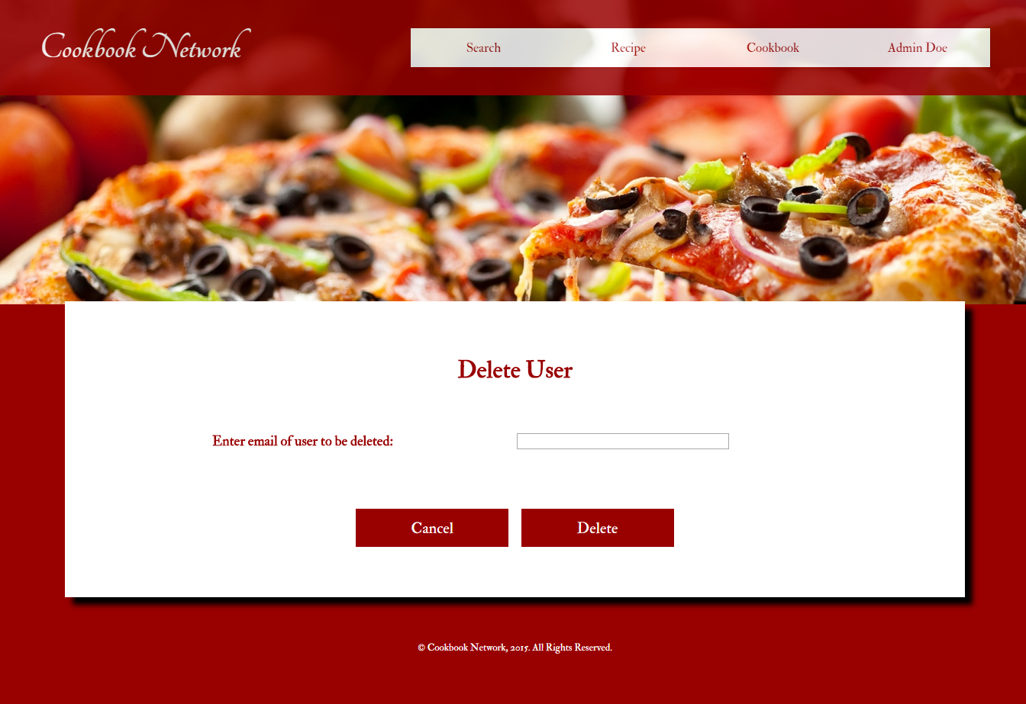

**Figure 38 -Delete User Account Page**

1. To delete, select Delete. and you will be taken to the Delete User Confirmation Page, Figure 39. To cancel, select Cancel. If you decide you want to cancel you will be taken to the previously visited page.

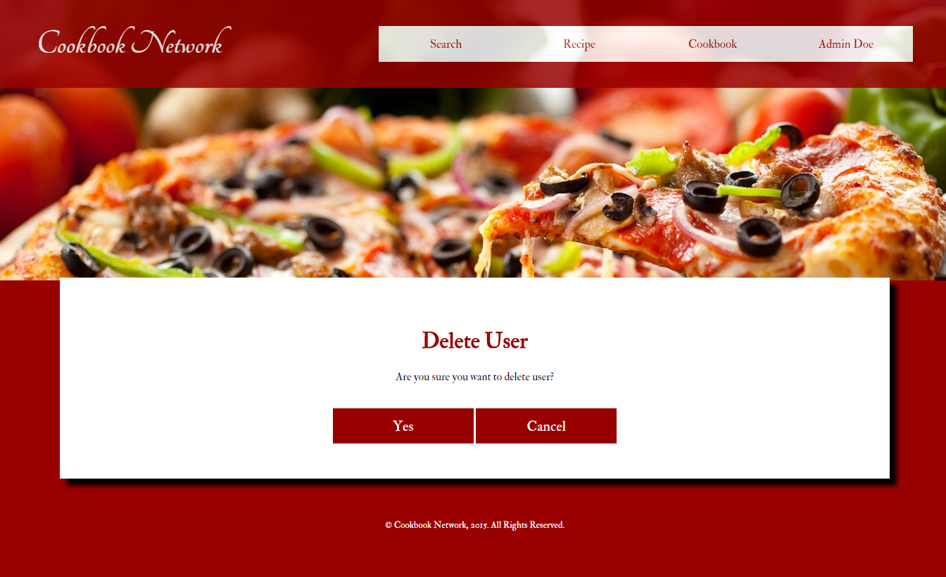

**Figure 39 -Delete User Confirmation Page**

1. On the confirmation page, select Yes to permanently delete the user’s account, including their recipes and cookbooks. Note, you can choose to cancel again, by select Cancel.
2. If the action was completed successfully, the search results will be displayed, like the one shown in Figure 19. If the action fails, a Failure Page will be displayed as shown in Figure 14. If latter is displayed then the user was not deleted because no account may exist with that email. Please try again. If the problem persists, please contact us using the help information at the end of the document.

# **V. Help**

*You may contact us for assistance in regards to Cookbook Network.*

If you happen to find any bugs, issues, or errors we’d be happy to hear about them!

**Contact Email**: help@cookbooknetwork.com

**Phone Number**: (123) 456 - 7890

# 

# 

# **VI. Database Tables**

